**df Command:**

* df: disk free
* df command reports file system disk space usage.

Command: df

By default, it will display figures (numbers) in KB.

* df command is used to determine file system disk space usage whereas du command is used to estimate/determine/find the size of file/directory.
* To display disk space usage in user specified memory blocks,

Command: df -B <block size>

Example: df -B 100 : It will display disk space in 100 bytes block.

* To display all file system disk space usage,

Command: df -a

* To display disk space usage in human readable format,

Command: df -h

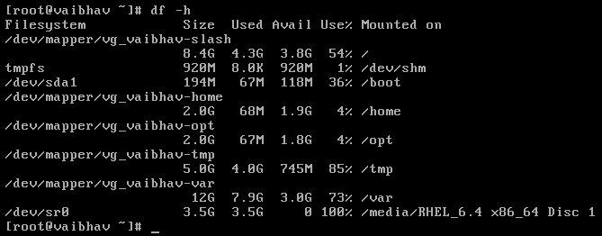

* To display disk space usage in Kilobytes (KB),

Command: df -k

* To display disk space usage in Megabytes (MB),

Command: df -m

* To display file system inodes,

Command: df -i

* To display grand total in output,

Command: df -h --total

df -i --total

* To display type of file system,

Command: df -T

* To display only certain file system type(include certain file system type),

Command: df -t <type_of_file system>

Example: df -t ext4 : It will display only ext4 disk space usage.

* Not to display certain file system type(include certain file system type),

Command: df -x <type_of_file system>

Example: df -x ext3 : It will not display ext3 disk space usage.